Simran Shilky

9918103027

F1

**Practice Lab 1**

Q1)#importing requests and beautiful soup, and setting up soup using #HTML parser

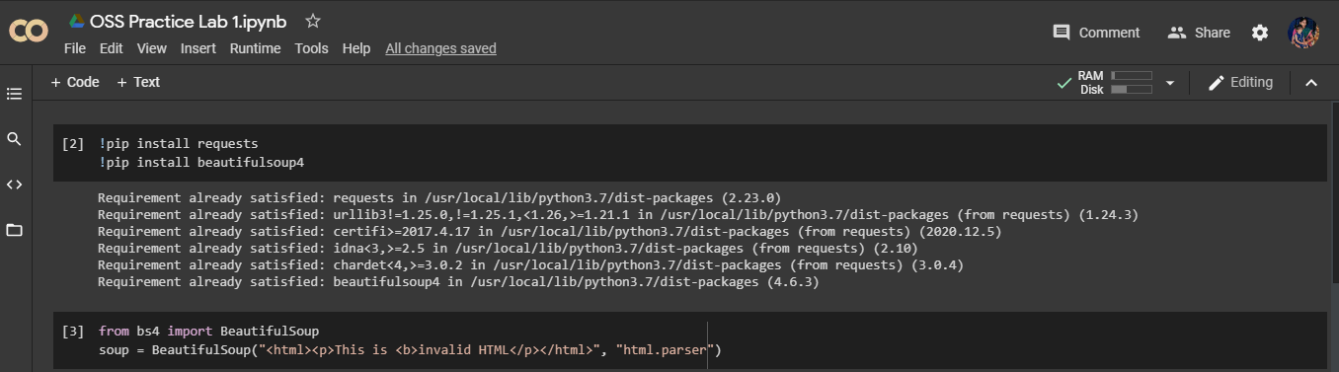

Q2)#Extracting URL’s from any website

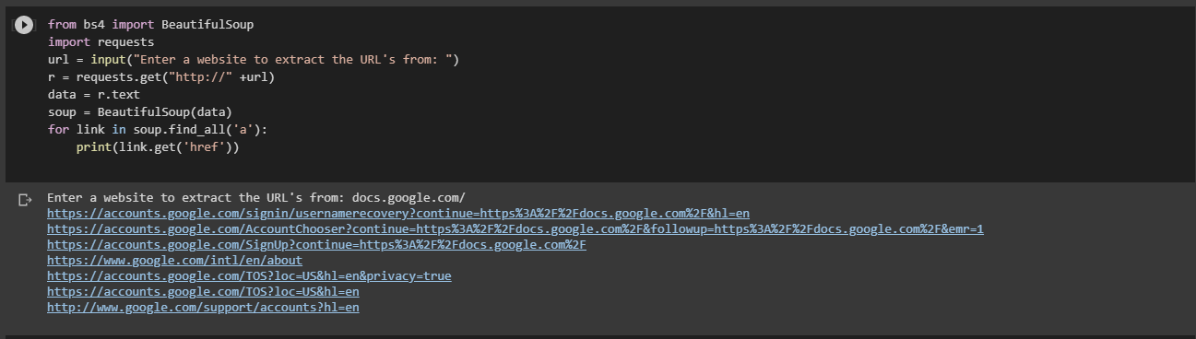

Q3)#Extracting titles, links, and headers from the website

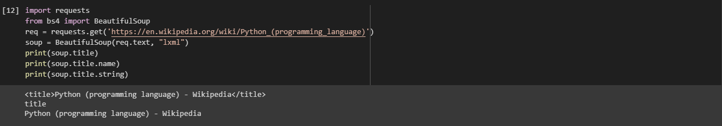

Q4)Extracting the main heading of the first paragraph



Q5)